Syllabus for MATH 1342

- COURSE RUBRIC & NUMBER: MATH 1342

- COURSE TITLE: Statistics

- COURSE DESCRIPTION: This is an introduction to the use of statistics in business and computer science. Topics include descriptive statistics, probability distributions, estimation and statistical tests, and analysis of variance (ANOVA). Additional topics selected from regression correlation, and non-parametric statistical methods will be reviewed.

- PREREQUISITES AND/OR CO-REQUISITES: Pre- or co-requisites: MATH 1314

- STUDENT LEARNING OUTCOMES: Upon completion of the course, students will be able to:
- Summarize and interpret sets of qualitative and quantitative data.
- Compute and interpret descriptive statistics on data sets.
- Use the basic rules of probability to compute the probability of an event.
- Compute and interpret the expected value and variance of a random variable.
- Use the binomial probability function and the binomial tables to obtain probabilities.
- Use the standard normal probability distribution to compute probabilities.
- Construct and interpret an interval estimate of a parameter.
- Use sample results to test hypotheses about a parameter.

- GENERAL EDUCATION OUTCOMES:
A. READING: Reading at the college level means the ability to analyze and interpret a variety of printed materials;
B. WRITING: Competency/outcome in writing is the ability to produce clear, correct, and coherent prose adapted to purpose, occasion, and audience;
C. SPEAKING: Competence in speaking is the ability to communicate orally in clear, coherent, and persuasive language appropriate to purpose, occasion, and audience;
D. LISTENING: Listening at the college level means the ability to analyze and interpret various forms of spoken communication;
E. CRITICAL THINKING: Critical thinking embraces methods for applying both qualitative and quantitative skills analytically and creatively to subject matter in order to evaluate arguments and to construct alternative strategies; and
F. COMPUTER LITERACY: Computer literacy at the college level means the ability to use computer-based technology in communicating, solving problems, and acquiring information.

- 3 or more major exams…………………………………………………………………………..60-70%
- Comprehensive final examination…..………………………………………………………25-30%
- An average of daily work, daily tests, classroom participation or any criteria
designated by the instructor …………………………………………….……no more than 10%

TEXTBOOKS/MATERIALS: Required Text for South Campus:
Elementary Statistics: Picturing the World, 4/E by Ron Larson and Elizabeth Farber,
Prentice Hall, 2009.
Required: TI 83/84 or TI 86 Calculator.
SUGGESTED CALENDAR AND PROBLEM SETS FOR MATH 1342
for South Campus
Week | Topic Description | Page
1 | Chapter 1: Introduction to Statistics (1st day) Read | Read, No assignment
2 | Chapter 2: Descriptive Statistics (2-3 lectures) | 50 1-17, 27-31
 | Ch 2 Cont’d | 63 1-31 odds
 | Ch 2 Cont’d | 73 1-55 EOO
 | Ch 2 Cont’d | 92 1-43 odds
 | Ch 2 Cont’d | 109 1-35 EOO
3 | Chapter 3: Probability (2-3 lectures)
 | Ch 3 Cont’d | 142 1-61 odds
 | Ch 3 Cont’d | 154 1-29 odds
 | Ch 3 Cont’d | 165 1-25 odds
 | Ch 3 Cont’d | 178 1-51 odds
4 | ******************Test I*****************
5 | Chapter 4: Discrete Probability Distributions (2 Lectures.)
 | Ch 4. Cont’d | 216 7-31 odds
6 | Chapter 5: Normal Probability Distributions (2-3 Lectures)
 | Chap. 5 Cont’d | 249 15-61 odds
7 | Chap 5 cont’d | 256 1-29 odds
 | Chap 5 cont’d | 266 1-45 odds
 | Chap 5 cont’d | 278 1-37 odds
8 | ******************Test II*****************
9 | Chapter 6: Confidence Intervals (2 Lectures)
 | Chap. 6 cont’d | 318 27-63 odds
 | Chap. 6 cont’d | 330 13-27 odds
 | Chap. 6 cont’d | 339 1-27 odds
 | Chap. 6 cont’d | 348 7-19 odds
10 | Chapter 7: Hypothesis Testing with One Sample (2-3 Lectures)
 | Chap. 7 cont’d | 376 23-49 odds
 | Chap. 7 cont’d | 389 1-45 EOO
 | Chap. 7 cont’d | 403 1-33 odds
 | Chap. 7 cont’d | 411 1-15 odds
 | Chap. 7 cont’d | 421 1-23 odds
11 | ******************Test III*****************
12 | Chapter 8: Hypothesis Testing with Two Samples(2-3 Lectures)
 | Chap. 8 cont’d | 444 1-33 odds
 | Chap. 8 cont’d | 456 1-23 odds
 | Chap. 8 cont’d | 466 1-19 odds
 | Chap. 8 cont’d | 475 1-23 odds
13 | Chapter 9: Correlation and Regression (1 Lectures)
 | Chap. 9 cont’d | 510 15-27 odds
 |  | 518 13-21 odds
14 | Chapter 10: Chi-Square Tests and the F-Distribution
 | Ch 10 Cont’d | 560 7-17 odds
 | Ch 10 Cont’d
15 | ******************Test IV*****************
16 | Final Examination (See course Catalog)

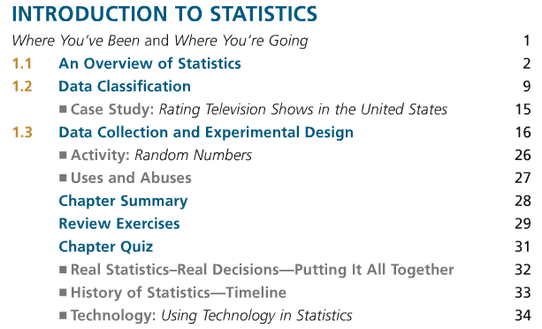
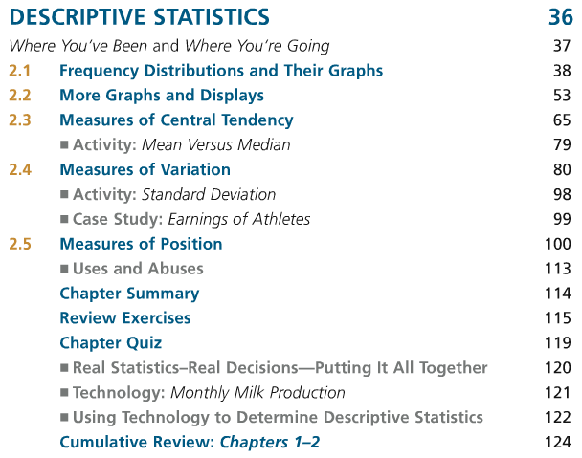
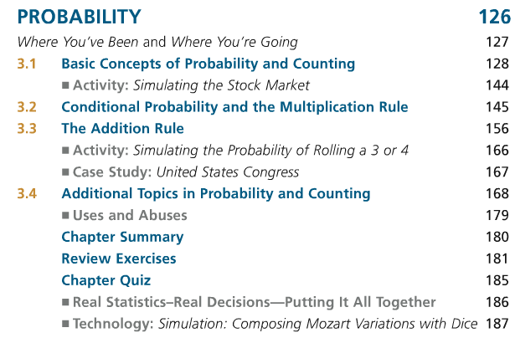
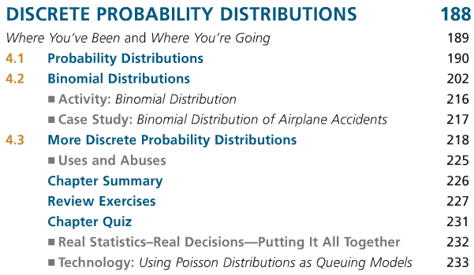
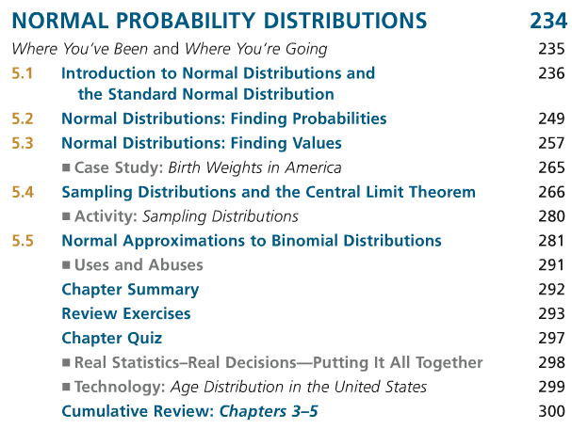
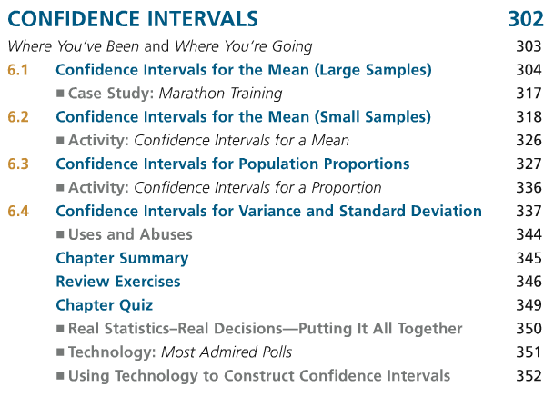
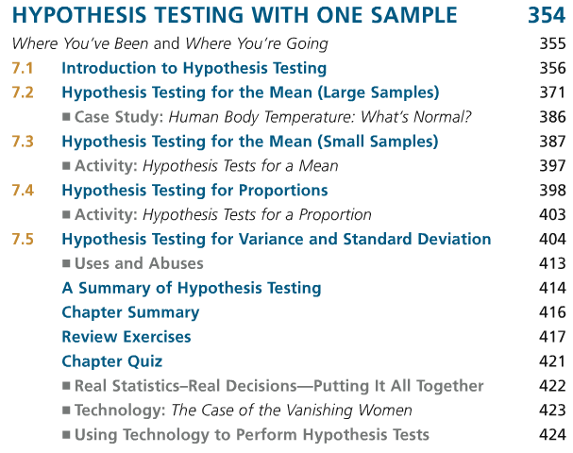
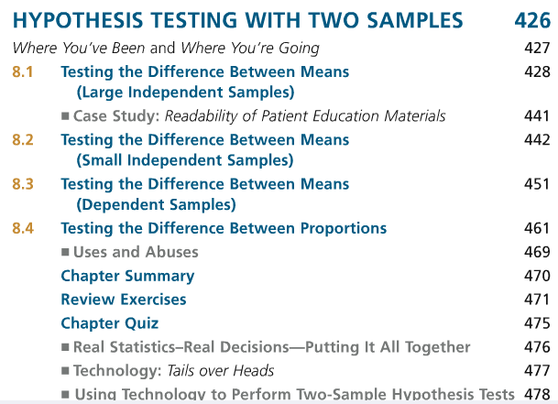
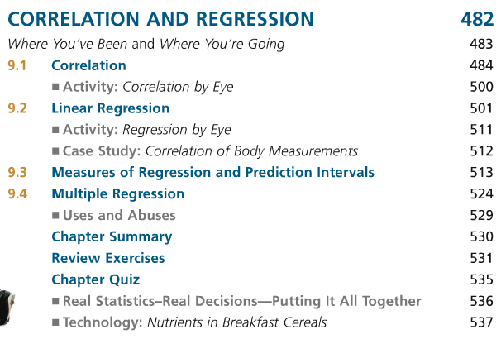
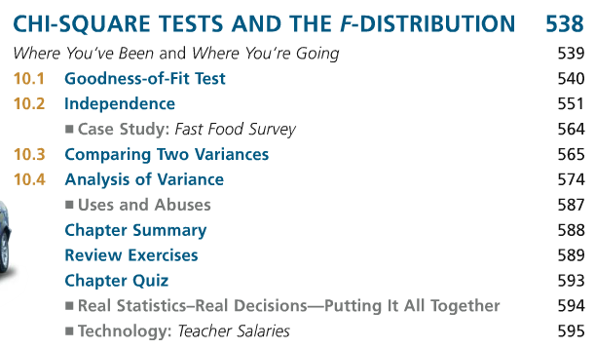
Supplementary and Reference Materials (Non-required)
Freund, John E. and Simon, Gary A. Modern Elementary Statistics, 10th edition, Prentice Hall, 2003.
McLave and Sincich, Statistics, 9th Edition, Prentice Hall, 2003
Triola, Mario, Elementary Statistics, 9th Edition, Addison Wesley,2004

Section 1.2
Section 1.3 Section 1.4 Section 1.5
Chapter 2 Section 2.2 Section 2.3 Section 2.4 Section 2.5
Chapter 3 Section 3.2 Section 3.3 Section 3.4
Exam 1
Chapter 4 Section 4.2 Section 4.3 Section 4.4 Section 4.5 Section 4.6
Chapter 5 Section 5.2 Section 5.3 Section 5.4
Chapter 6 Section 6.2 Section 6.3 Section 6.4 Section 6.5 Section 6.6 Section 6.7
Exam 2
Chapter 7 Section 7.2 Section 7.3 Section 7.4
Chapter 8 Section 8.2 Section 8.3 Section 8.4 Section 8.5
Chapter 9 Section 9.2 Section 9.3 Section 9.4
Exam 3
Chapter 10 Section 10.2 Section 10.3 Section 10.4
Chapter 11 Section 11.2 Section 11.3 Section 11.4
Exam 4

